# Project Design Phase-II Technology Stack (Architecture & Stack)

|  |  |
| --- | --- |
| Date | 19 September 2022 |
| Team ID | PNT2022TMID28961 |
| Project Name | Gas Leakage monitoring & Alerting system for Industries |
| Project TEAM members | K.Bala Suresh F.Pratheesh M.Sowmiya M.Ranishka |

**Architecture:**

**Technical Architecture:**

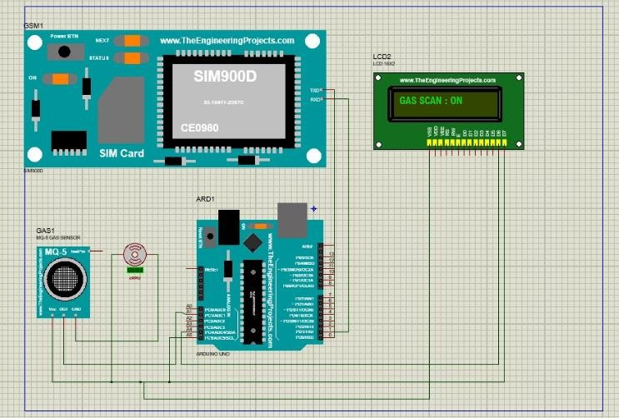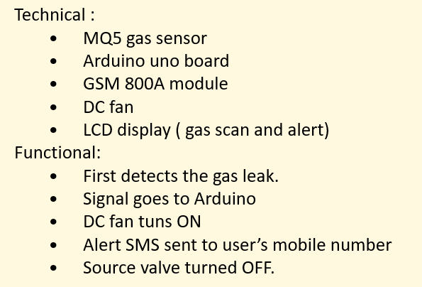

# DEVELOPMENT OF TASK ANALYSIS:

**Hardware Requirements**

1. Arduino UNO Microcontroller
2. Green LED 1, Red LED 3
3. 9V Power supply (230V TO 9V STEPDOWN TRANSFORMER)
4. MQ6 Gas sensor
5. GSM 800 Module
6. GSM Sim
7. Connecting wires
8. Project base

# Software Requirements

1. Arduino IDE
2. Language C++

# WORKING:

**Step 1**: A signal from the microcontroller will go to the display and show gas leakage message there.

**Step 2**: Simultaneously automatically turns on the DC fan to ventilate the leaked gas, and the source solenoid valve will be turns off

**Step 3**: Signal from microcontroller activates the GSM module and sends an alert SMS “ALERT GAS LEAKING” to the user’s mobile number.